APACHE KAFKA HANDS-ON ASSIGNMENT
C# Kafka Chat Application – Producer and Consumer

1. Objective
Configure Apache Kafka in KRaft mode on Windows, create a Kafka topic, develop a C# producer, send messages to Kafka, and verify them using a Kafka console consumer.

2. Requirements
Apache Kafka 4.3.1
OpenJDK 21 (64-bit)
.NET SDK / C#
Visual Studio Code
Confluent.Kafka NuGet package
Windows Command Prompt

3. Kafka Configuration
Important config/server.properties settings:
process.roles=broker,controller
node.id=1
controller.quorum.bootstrap.servers=localhost:9094
listeners=PLAINTEXT://:9092,CONTROLLER://:9094
advertised.listeners=PLAINTEXT://localhost:9092
inter.broker.listener.name=PLAINTEXT
controller.listener.names=CONTROLLER
listener.security.protocol.map=CONTROLLER:PLAINTEXT,PLAINTEXT:PLAINTEXT
log.dirs=C:/kafka/kraft-combined-logs
num.partitions=1

4. Initialize KRaft Storage
C:\kafka>bin\windows\kafka-storage.bat random-uuid
F3nsECj7RW29SxZAnYuLiA
C:\kafka>bin\windows\kafka-storage.bat format --standalone -t F3nsECj7RW29SxZAnYuLiA -c config\server.properties

5. Kafka Heap Setting
set KAFKA_HEAP_OPTS=-Xms1g -Xmx3g

6. Start Kafka Server
C:\kafka>bin\windows\kafka-server-start.bat config\server.properties
Successful startup was confirmed by "Transition from STARTING to STARTED" and "Kafka Server started".

7. Create Topic
C:\kafka>bin\windows\kafka-topics.bat --create --topic chat-topic --bootstrap-server localhost:9092
Output: Created topic chat-topic.

8. Create C# Project and Install Package
dotnet new console -n KafkaChatApp
cd KafkaChatApp
dotnet add package Confluent.Kafka

9. Program.cs
using System;
using System.Threading.Tasks;
using Confluent.Kafka;
class Program
{
static async Task Main(string[] args)
{
var config = new ProducerConfig
{
BootstrapServers = "localhost:9092"
};
using var producer =
new ProducerBuilder<Null, string>(config).Build();
Console.WriteLine("================================");
Console.WriteLine(" KAFKA CHAT APPLICATION");
Console.WriteLine("================================");
Console.WriteLine("Type your message and press Enter.");
Console.WriteLine("Type 'exit' to close the chat.");
Console.WriteLine();
while (true)
{
Console.Write("You: ");
string? message = Console.ReadLine();
if (string.IsNullOrWhiteSpace(message))
continue;
if (message.Equals("exit", StringComparison.OrdinalIgnoreCase))
break;
try
{
var result = await producer.ProduceAsync(
"chat-topic",
new Message<Null, string>
{
Value = message
});
Console.WriteLine($"Message sent to Kafka: {message}");
}
catch (ProduceException<Null, string> ex)
{
Console.WriteLine($"Kafka Error: {ex.Error.Reason}");
}
}
}
}

10. Run Application
dotnet run
Test message used: "Hello from C# Kafka Chat".

11. Consumer Verification
C:\kafka>bin\windows\kafka-console-consumer.bat --topic chat-topic --from-beginning --bootstrap-server localhost:9092
The consumer displayed the messages sent by the C# producer, verifying the complete Producer → Topic → Consumer flow.

12. Screenshots
Kafka configuration
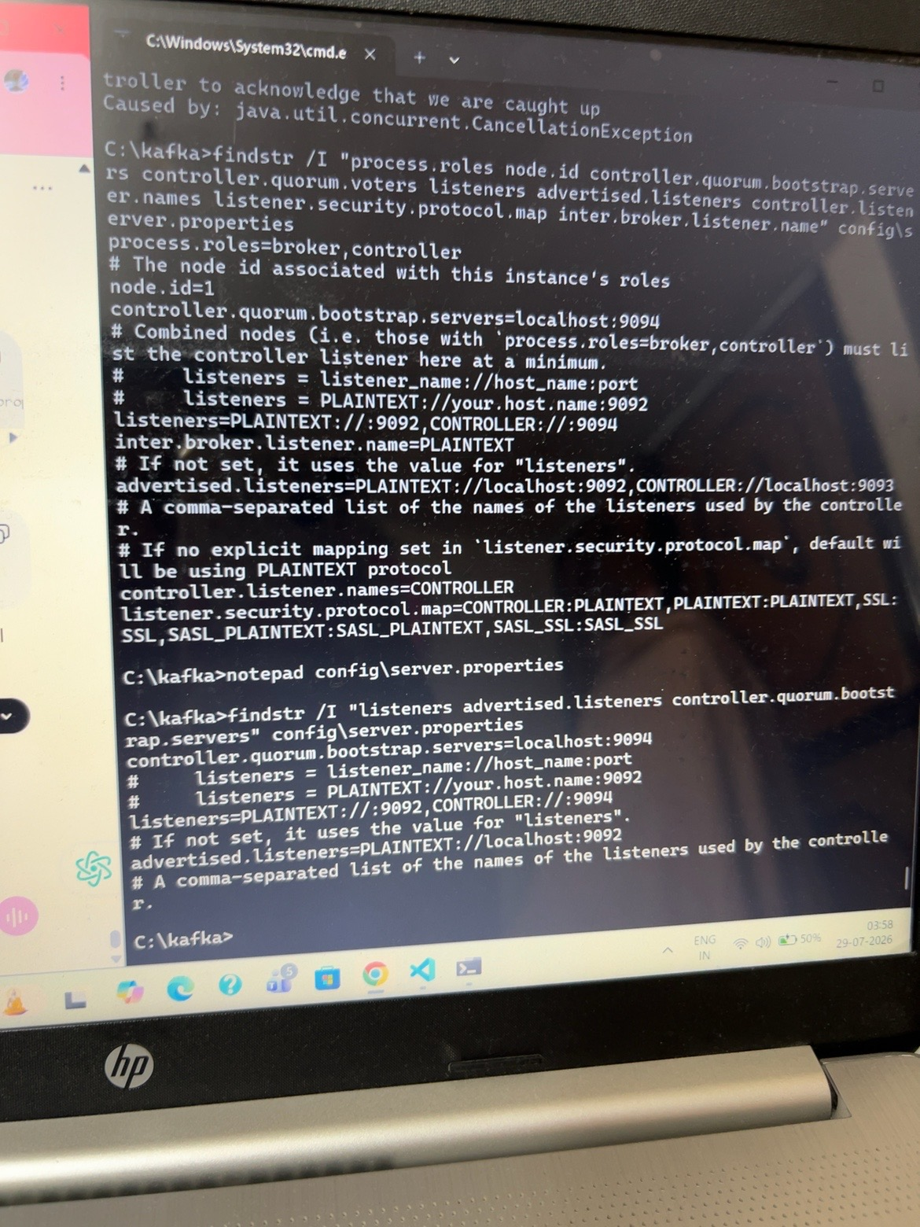
Kafka server started successfully
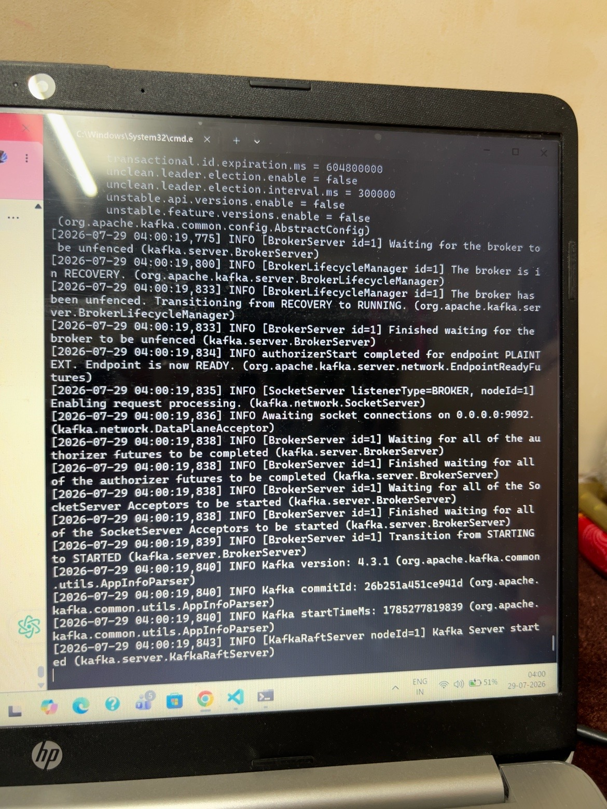
C# producer sending messages
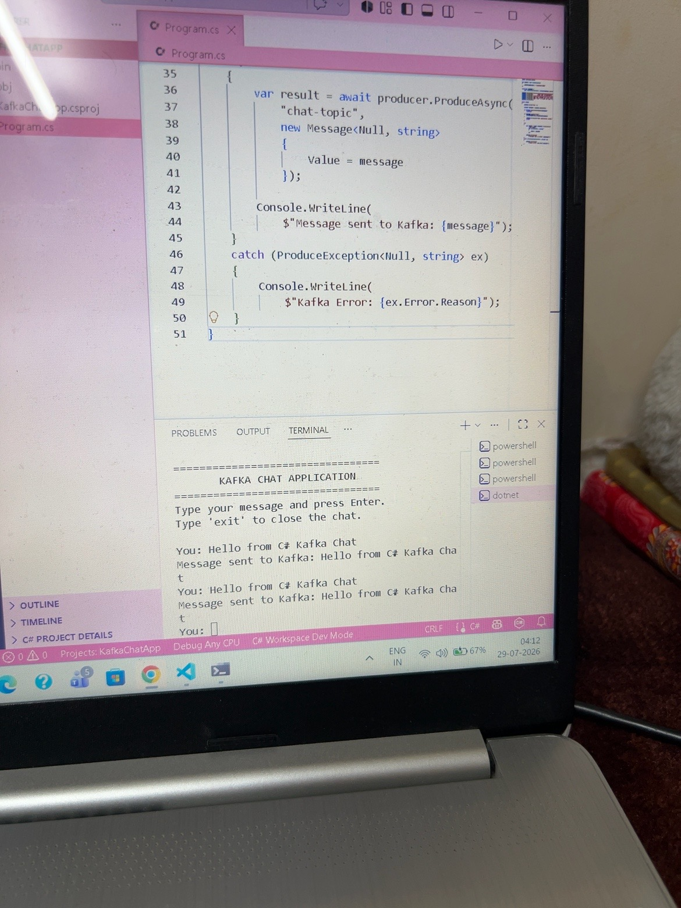
Kafka consumer receiving messages
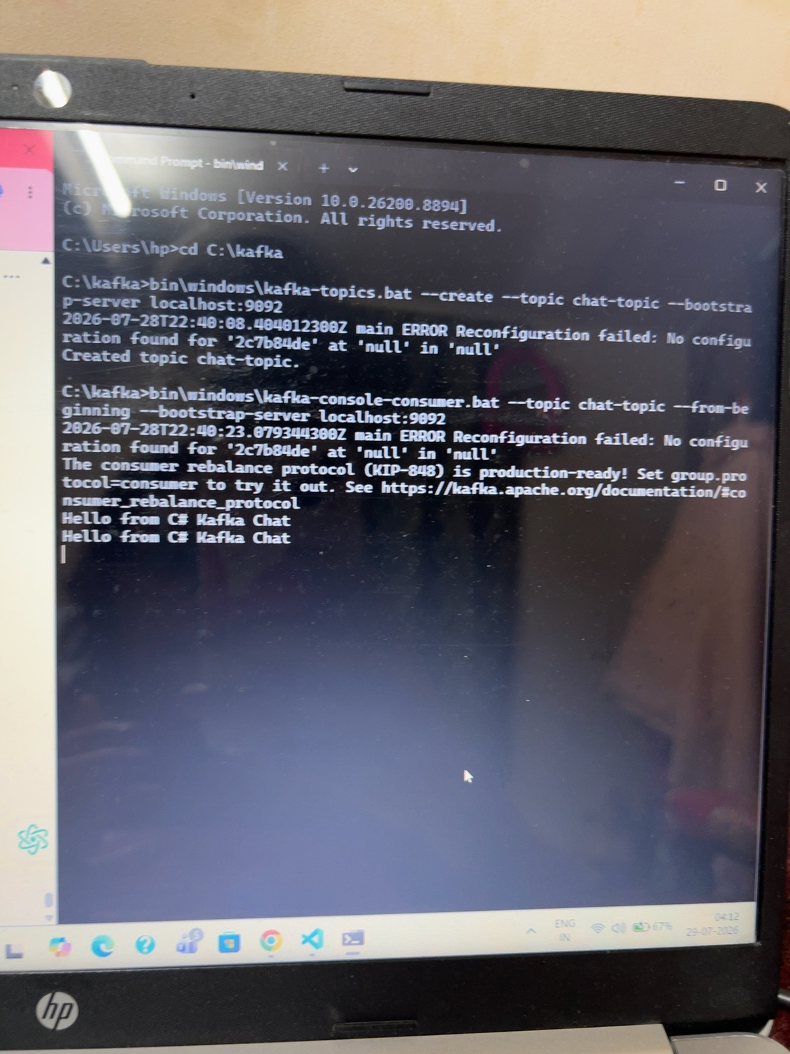

13. Result
Apache Kafka was configured successfully in KRaft mode. The chat-topic topic was created, the C# producer published messages, and the Kafka console consumer received the messages successfully. The hands-on assignment was completed successfully.

14. Additional Implementation and Output Screenshots
The following screenshots show the final C# producer source code, the running Kafka chat application, and the Kafka console consumer receiving the produced messages.
Kafka topic creation and console consumer output showing messages received from the C# application.
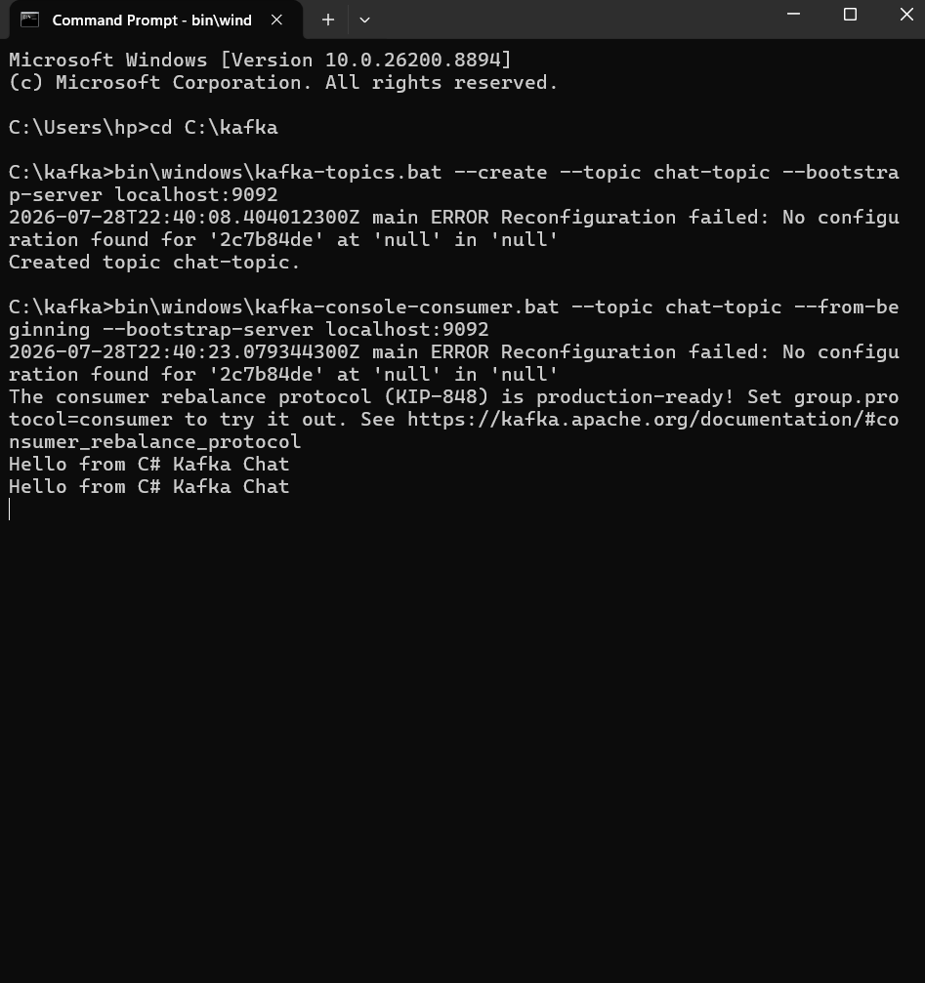
Program.cs – C# Kafka producer configuration and chat application logic.
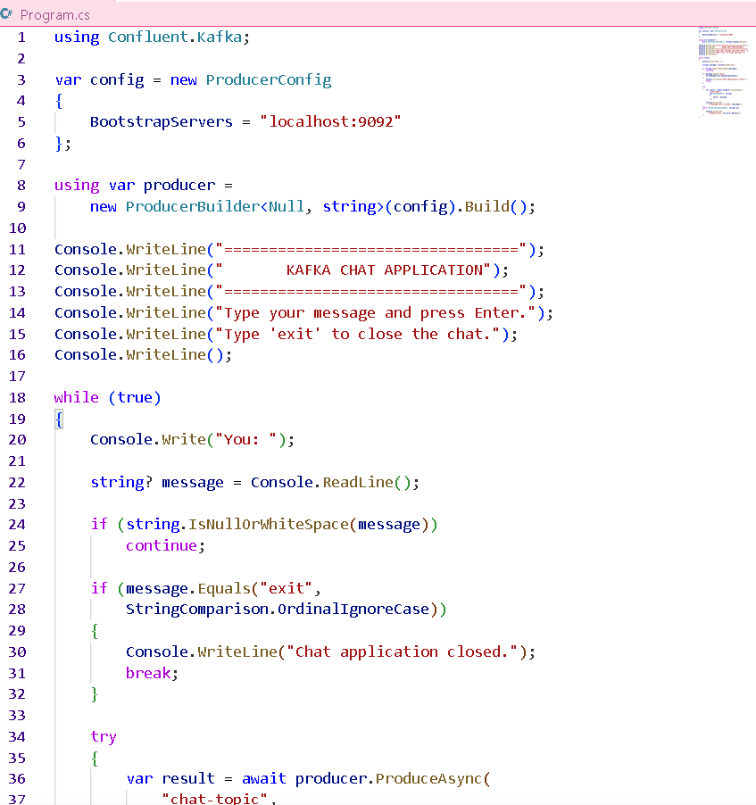
Program.cs – ProduceAsync call and exception handling for Kafka message production.
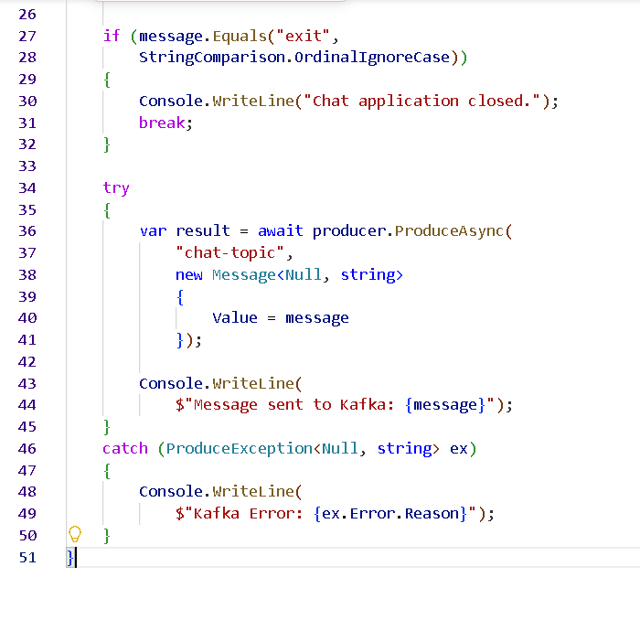
Final KafkaChatApp execution in Visual Studio Code showing successful messages sent to Kafka.
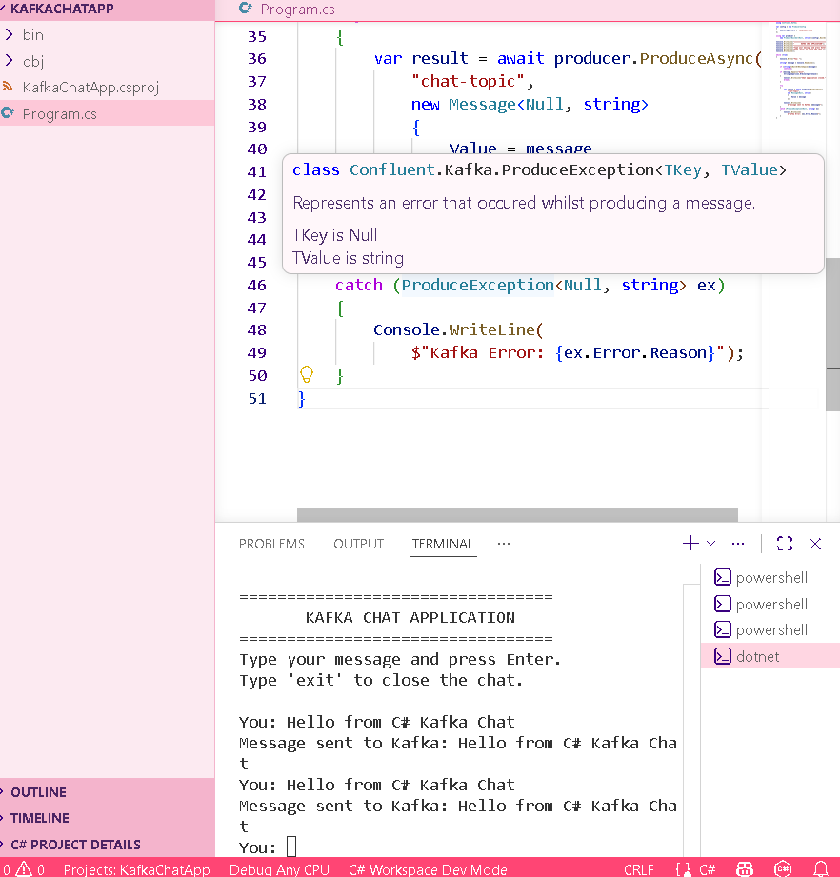

15. Final Verification
The screenshots verify that the chat-topic topic was created successfully, the C# producer connected to localhost:9092 and sent messages to Kafka, and the Kafka console consumer received the same messages. Therefore, the complete Kafka producer-consumer hands-on implementation is working successfully.

